Seepage Measurement System
Water flow monitoring in open channels is widely employed in environmental and geotechnical field. Leakage measurement is one of the most important indicators of the overall performance of earth/rock-fill and concrete dams.
The leakage rate is a function of the water level in the reservoir and depends on the construction than the behavior of the dam.
Consequently, leakage monitoring provides data for the evaluation of the long-term stability of the dam constructions.

INTRODUCTION:

FEATURES:
V- Notch
- Suitable for both manual reading and remote monitoring.
- Available for both triangular and rectangular notch plate.
- Utilize high accuracy transducer.

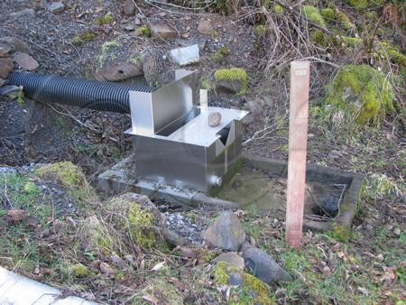
DESCRIPTION:
Notched weirs operate on the principle that an obstruction in a canal will cause a hydraulic jump, creating a high level behind the barrier with a typical low water current (no turbulent motion). The purpose of the notched weir is to transform the water level in the upstream basin into instantaneous flow values of the canal where the weir is installed. To allow this, a specific formula is used: it considers that the flow rate is function of the notch shape and proportional to the water depth “H”, called head.

V- Notch Setup

SPECIFICATIONS:

Range  Operating Temperature  Material  Ordering Information | Up to 100 litre/second  -300C to 85 0C  All Stainless Steel
Dimensions and ranges are nominal only and can be modified to suit project requirements.

